 | 2026 Jemena Community Grants Program  Aboriginal and Torres Strait Islander Initiatives  Application Form | 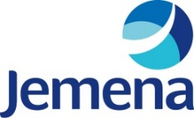

IMPORTANT INFORMATION
Before submitting an application, please ensure that you have read and accept our Community Grants Guidelines – Aboriginal and Torres Strait Islander Initiatives and Terms and Conditions, found on the Jemena website. For any questions, email community@jemena.com.au.

 | Grants open: 27 May 2026, 9am AEST | Grants close: 21 June 2026, 5pm AEST

Your details
First, please tell us a bit about you and the group you represent:
Organisation name
Address |  | Suburb
State |  | Postcode
ABN |  | Website
Where is your project located?

Applicant name |  | Role title
Phone number |  | Email

Applying for a grant as a:
☐ Not-for-profit organisation |  | ☐ Registered charity |  | ☐ School | ☐ Community group
☐ Other (please describe)
Have you applied for a Jemena grant in the past? |  |  |  | ☐ Yes | ☐ No
Have you confirmed your group’s permission to apply? |  |  |  | ☐ Yes | ☐ No
How did you hear about our Jemena Community Grants – Aboriginal and Torres Strait Islander Initiatives?
☐ Online ads | ☐ Social media |  | ☐ Jemena website |  | ☐ Jemena employee
☐ Grant listing sites | ☐ Local Council or MP |  | ☐ Other (please tell us where):

Grants category and funding

2026 Community Grants categories – Aboriginal and Torres Strait Islander Initiatives
You can apply for a grant for up to $10,000
Apply if you’re seeking funding for activities focused on Aboriginal and Torres Strait Islander Peoples that:
- support education, training and/or work opportunities that support people into jobs
- help create jobs in communities, including social enterprises, or
- provide support services or emergency assistance (for example, food pantries).

Applicants are not required to hold status as Indigenous-led or Aboriginal-controlled organisations, but applications supported by this status may be given special consideration. Organisations are encouraged to support their application by providing information about your status as an Indigenous-led or Aboriginal-controlled organisation, as well as their purpose and mission related specifically to supporting Indigenous Australians.

Applicants must be based in our operational areas in New South Wales, Victoria, Queensland and the Northern Territory – see below for location information.
How much funding are you asking for? | $

Assessment Criteria
In this section, please tell us about the activity you are applying for:
- What does your organisation or group do? (150 words max)
Please include:
- a short description of your organisation or group and its purpose and goals
- how your organisation helps Aboriginal and Torres Strait Islander Peoples, including whether your organisation is Indigenous-led or your vision and mission

- What benefits will your activity deliver, and how? (400 words max)
Please outline
- the project or initiative you are seeking funding for, and what activities you plan, in which locations
- the benefits your program will deliver (for example, how many people will you help and how you will help them, what changes you are trying to make in communities)
- how the grant will be used to support your activity (will the grant cover all costs, are you applying for other grants, will it be used to support only parts of the activity)?

- How will you measure the success, outcomes and impacts of your activity? (150 words max)

Please describe how you plan to show your activity is successful, for example, will you track and report on the number of people who participate, issue before & after surveys to measure knowledge or changes in behaviour?

- What opportunities are there for Jemena to participate in or promote the activity? (150 words max)
For example, participate in events, feature branding in activities, social media or media coverage

Additional information (optional)

If applicable, please provide information about your status as an Indigenous-led or Aboriginal-controlled organisation, as well as your purpose and mission related specifically to supporting Indigenous Australians. This could include:
- registration under the Corporations (Aboriginal and Torres Strait Islander) Act 2005, or
- similar state-based legislation, or
- your vision or mission statement showing your focus on supporting Aboriginal and Torres Strait Islander peoples.
Depending on the nature of your activity you may wish to provide extra information to support your application (for example, related brochures or ad materials). This is entirely optional and can be attached to your email application.

Submitting your application

Once completed, please email:
- this form
- any additional information you wish to share
- a letterhead confirming your organisation’s not-for-profit, charity status, educational and / or ABN detail
- any other relevant information

to community@jemena.com.au.

We’ll then review your application against our Community Grants Guidelines, application criteria, terms and conditions and broader community strategy to come back with any questions, and provide you with a response within 60 days of the grants closure date. For any questions just contact us.

Please note that due to limited funding, not every application that meets the criteria may receive a grant.

Who is Jemena
At Jemena, we help bring energy to life for almost 2 million Australian homes and businesses every day. With a presence across various parts of eastern and northern Australia, we’re also a proud member of hundreds of wonderful and diverse local communities. For more information, visit www.jemena.com.au

What locations are eligible for grants?
New South Wales  To check you are located in one of Jemena’s New South Wales gas operating areas, visit the below link and type your address into the ‘Find your distributor’ search bar:  https://www.jemena.com.au/gas/  We are also making grants available to selected communities where our gas transmission assets/operations are located: Michelago (2620)  Mila (2632). | 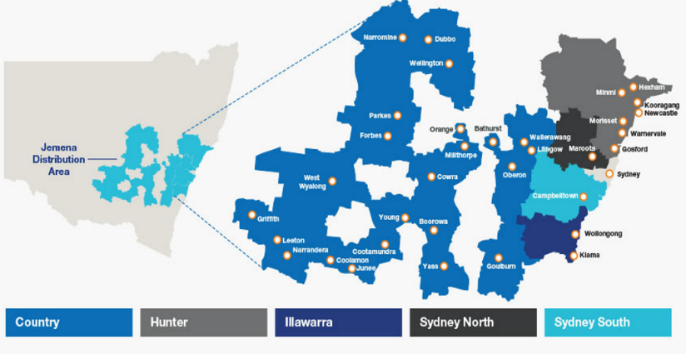
Victoria  To check if you are located in Jemena’s Victorian electricity operating area, visit the below link and type your address into the ‘Find your distributor’ search bar:  https://www.jemena.com.au/electricity/  We are also making grants available to organisations in selected communities near where our gas transmission assets/operations are located:  Sale (3850),  Longford (3851)  East Sale (3852). | 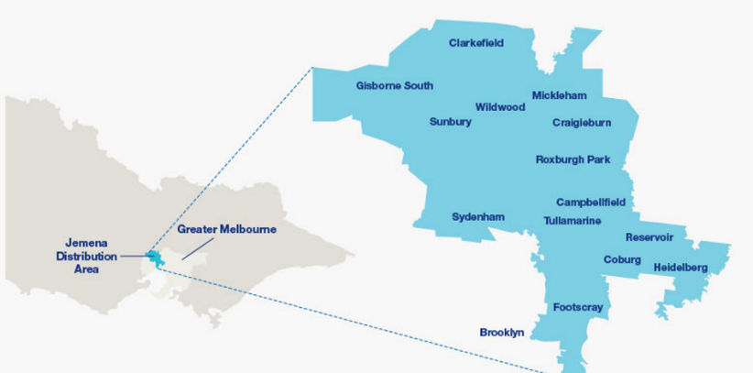

Victoriao check if you are located in Jemena’s Victorian electricity operating area, visit the below link and type your address into the ‘Find your distributor’ search bar:
Northern Territory and Queensland

We are making grants available to organisations near where our gas transmission assets and operations are located. These include:
- Tennant Creek and surrounding areas (0860)
- Mt Isa and surrounding areas (4285)
- Maryborough (4650), Rockhampton (4700), Rolleston (4702), Biloela (4715), Gladstone (4860)
- Dalby (4405), Wandoan (4419), Roma (4455)

We are also making grants available to organisations in selected communities near where our gas transmission assets/operations are located: Sale (3850), Longford (3851) and East Sale (3852).

